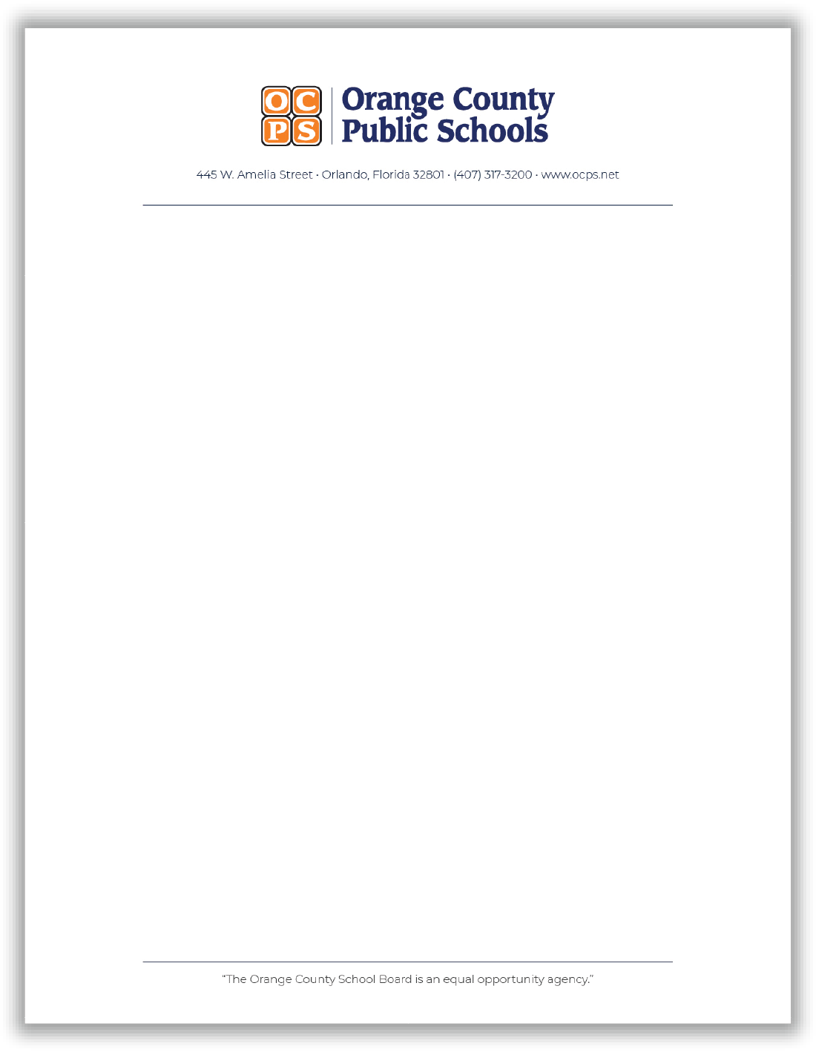

Orange County Public Schools purchases rights, on a yearly basis, to music from the DeWolfe Music and Westar Music libraries. Each contract provides OCPS schools and the district office with the rights to use the music for broadcast, cable, duplication and contest entries. Copies of the individual contracts are available from the OCPS Purchasing department. Questions can be directed to Jackelyn Juvinall.

Jackelyn Juvinall
Orange County Public Schools
Video Services Department
445 W. Amelia St.
Orlando, FL 32801
407-317-3478
Jackelyn.Juvinall@ocps.net

